**Test Case 0049 (part 1)**

**System:** VirtuCardsClient & VirtuCardsHost

**Description:** test that ensures that the sound effects occur in sync with the game actions.

**Severity:** 3

**Instructions**

1. Start VirtuCardClient application
2. Click the button labeled “Sign In”
3. Enter “virtucards01@gmail.com” into the text input labeled “Enter email…”
4. Enter “Testing1” into the text input labeled “Enter password…”
5. Press the button labeled “Login”
6. A window should appear saying “Login Success”
7. Press the OK button that appears on that window
8. Press the OK button that appears on that window
9. Press the Profile Icon on the top left side
10. Press back button
11. Repeat steps 2-7 with “[micro@soft.com](mailto:micro@soft.com)” and “Password!123”
12. Start VirtuCardHost application
13. Repeat steps 2-7 but on the VirtuCardHost application
14. The checkbox “Allow Host to Join” should be checked on the host
15. Press the Create Game button
16. In the VirtuCardClient application enter the 6-character room code found on the host’s screen into the field labeled “Enter Code…”
17. Press the Join Game button on the both clients
18. After the name TestCase0001 and billy123 appears in the player list on the host side, press the Start Game button

**Expected Result:** When the host starts the game, there will be a sound effect that will play on everybody’s client device when the game has started.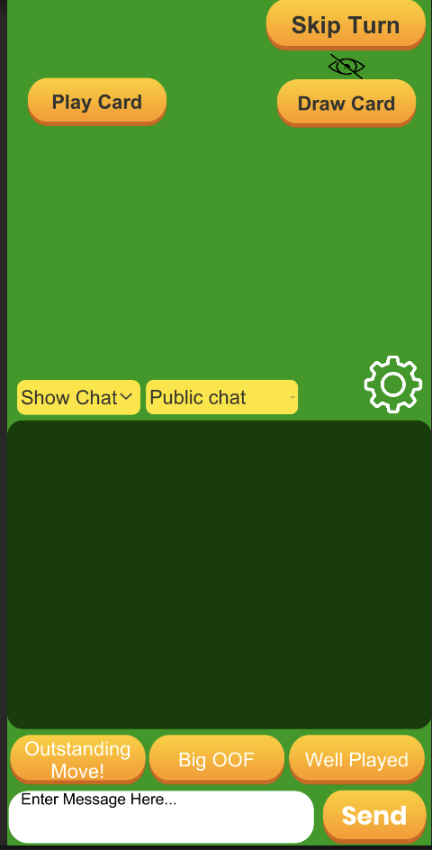

**Test Case 0049 (part 2)**

**System:** VirtuCardsClient & VirtuCardsHost

**Description:** test that ensures that the sound effects occur in sync with the game actions.

**Severity:** 3

**Instructions**

1. Start VirtuCardClient application
2. Click the button labeled “Sign In”
3. Enter “virtucards01@gmail.com” into the text input labeled “Enter email…”
4. Enter “Testing1” into the text input labeled “Enter password…”
5. Press the button labeled “Login”
6. A window should appear saying “Login Success”
7. Press the OK button that appears on that window
8. Press the OK button that appears on that window
9. Press the Profile Icon on the top left side
10. Press back button
11. Repeat steps 2-7 with “[micro@soft.com](mailto:micro@soft.com)” and “Password!123”
12. Start VirtuCardHost application
13. Repeat steps 2-7 but on the VirtuCardHost application
14. The checkbox “Allow Host to Join” should be checked on the host
15. Press the Create Game button
16. In the VirtuCardClient application enter the 6-character room code found on the host’s screen into the field labeled “Enter Code…”
17. Press the Join Game button on the both clients
18. After the name TestCase0001 and billy123 appears in the player list on the host side, press the Start Game button
19. Send a private message to billy123 from TestCase0001

**Expected Result:** When TestCase0001 sends a private message to billy123, billy123 will get a unique audio to indicate that the person has received a private message from a different user in the game. For testing purposes, we have altered the code that you can send private messages to yourself.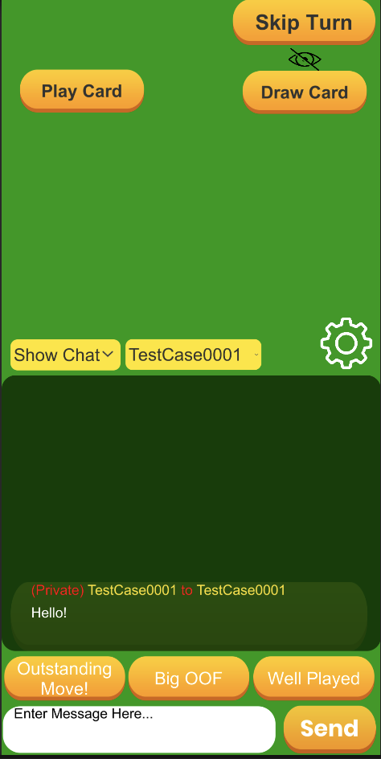

**Test Case 0049 (part 3)**

**System:** VirtuCardsClient & VirtuCardsHost

**Description:** test that ensures that the sound effects occur in sync with the game actions.

**Severity:** 3

**Instructions**

1. Start VirtuCardClient application
2. Click the button labeled “Sign In”
3. Enter “virtucards01@gmail.com” into the text input labeled “Enter email…”
4. Enter “Testing1” into the text input labeled “Enter password…”
5. Press the button labeled “Login”
6. A window should appear saying “Login Success”
7. Press the OK button that appears on that window
8. Press the OK button that appears on that window
9. Press the Profile Icon on the top left side
10. Press back button
11. Start VirtuCardHost application
12. Repeat steps 2-7 but on the VirtuCardHost application
13. The checkbox “Allow Host to Join” should be checked on the host
14. Press the Create Game button
15. In the VirtuCardClient application enter the 6-character room code found on the host’s screen into the field labeled “Enter Code…”
16. Press the Join Game button on the both clients
17. After the name TestCase0001appears in the player list on the host side, press the Start Game button
18. Draw a card
19. Play the card

**Expected Result:** When the user has drawn a card, there will be an audio clip of the drawing card played, and when the user plays a card, it will play some sort of card playing noise.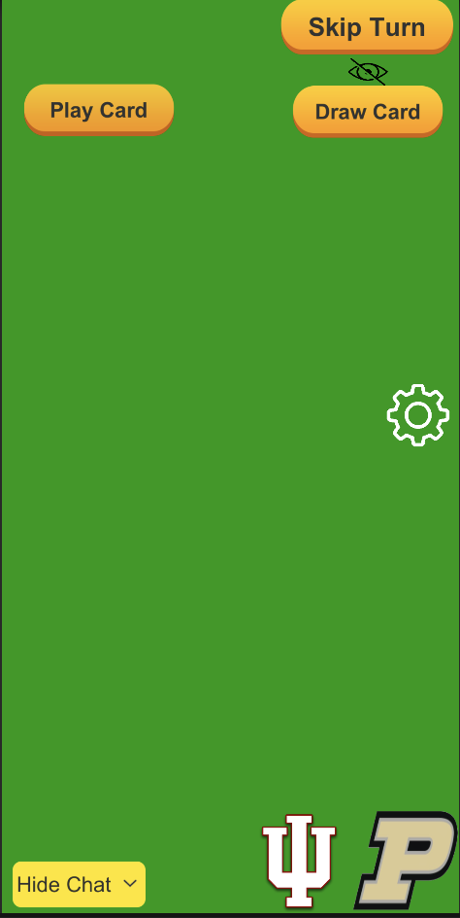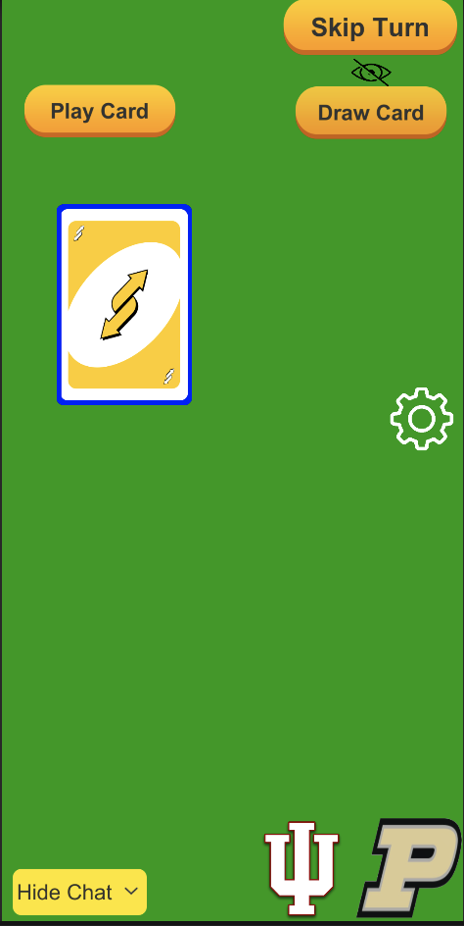

**Test Case 0049 (part 4)**

**System:** VirtuCardsClient & VirtuCardsHost

**Description:** test that ensures that the sound effects occur in sync with the game actions.

**Severity:** 3

**Instructions**

1. Start VirtuCardClient application
2. Click the button labeled “Sign In”
3. Enter “virtucards01@gmail.com” into the text input labeled “Enter email…”
4. Enter “Testing1” into the text input labeled “Enter password…”
5. Press the button labeled “Login”
6. A window should appear saying “Login Success”
7. Press the OK button that appears on that window
8. Press the OK button that appears on that window
9. Press the Profile Icon on the top left side
10. Press back button
11. Repeat steps 2-7 with “[micro@soft.com](mailto:micro@soft.com)” and “Password!123”
12. Start VirtuCardHost application
13. Repeat steps 2-7 but on the VirtuCardHost application
14. The checkbox “Allow Host to Join” should be checked on the host
15. Press the Create Game button on “Freeplay”
16. In the VirtuCardClient application enter the 6-character room code found on the host’s screen into the field labeled “Enter Code…”
17. Press the Join Game button on the both clients
18. After the name TestCase0001 and billy123 appears in the player list on the host side, press the Start Game button
19. Declare TestCase0001 as a winner

**Expected Result:** When TestCase0001 is declared as a winner, the user will get a notification from the host saying that he/she has won the game and will be able to hear victory audio clips to indicate that the person has won.